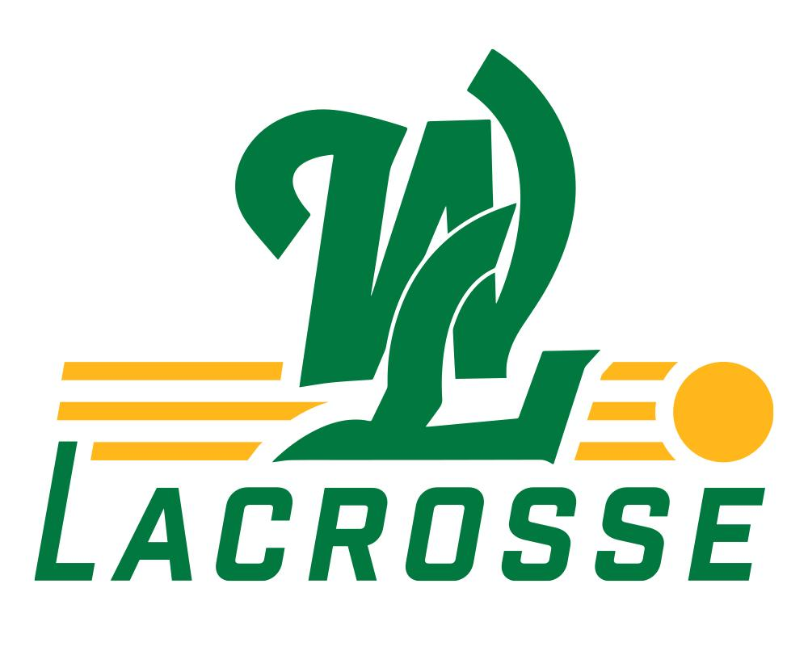

West Linn Girl’s Youth Player & Parent Code of Conduct

West Linn Youth Girls Lacrosse (WLYGL) supports the following behaviors for those who participate in the sport or are involved in any way with WLYGL. The following essential elements of the Code of Conduct must be followed:

- WLYGL is a recreational league. The primary focus of the season is on FUN and participation. The WLYGL program emphasizes concepts of fair play, skills of the game, player development and positive team culture. These priorities will not be sacrificed for the sake of a win.
- Sportsmanship and teaching the concepts of fair play are essential to the game and must be taught at all levels and developed both at home and on the field during practices and games.
- The value of good sportsmanship, the concepts of fair play, and the skills of the game should always be placed above winning.
- The safety and welfare of the players are of primary importance. Coaches must exercise sound judgment and make decisions in an effort to protect the safety and welfare of players.
- WLYGL is a volunteer run organization. Grievances or misunderstandings are expected to be handled with the utmost respect and should follow the proper channels. Players and parents should first attempt to address concerns with the coach. In the event further discussions are needed the WLYGL Board President should be notified: wlgylboard@gmail.com.
- Grievances or misunderstandings between coaches, officials or any other parties involved with the sport should be communicated through the proper channels and procedures, never on or about the field of play in view of players, spectators, or participants.
- Players should always demonstrate positive behavior and respect toward teammates, opponents, coaches, officials, parents and spectators.
- Players, parents and spectators are expected to demonstrate the utmost respect for officials and reinforce that respect to players/teammates.
- Spectators involved with the game must never permit anyone to openly or maliciously criticize, badger, harass or threaten an official, coach, player or opponent.
- Support the drug, alcohol and tobacco free environment that is important to all youth sporting events.

