Pleasant Grove Dolphins Football & Cheer Fundraising Agreement

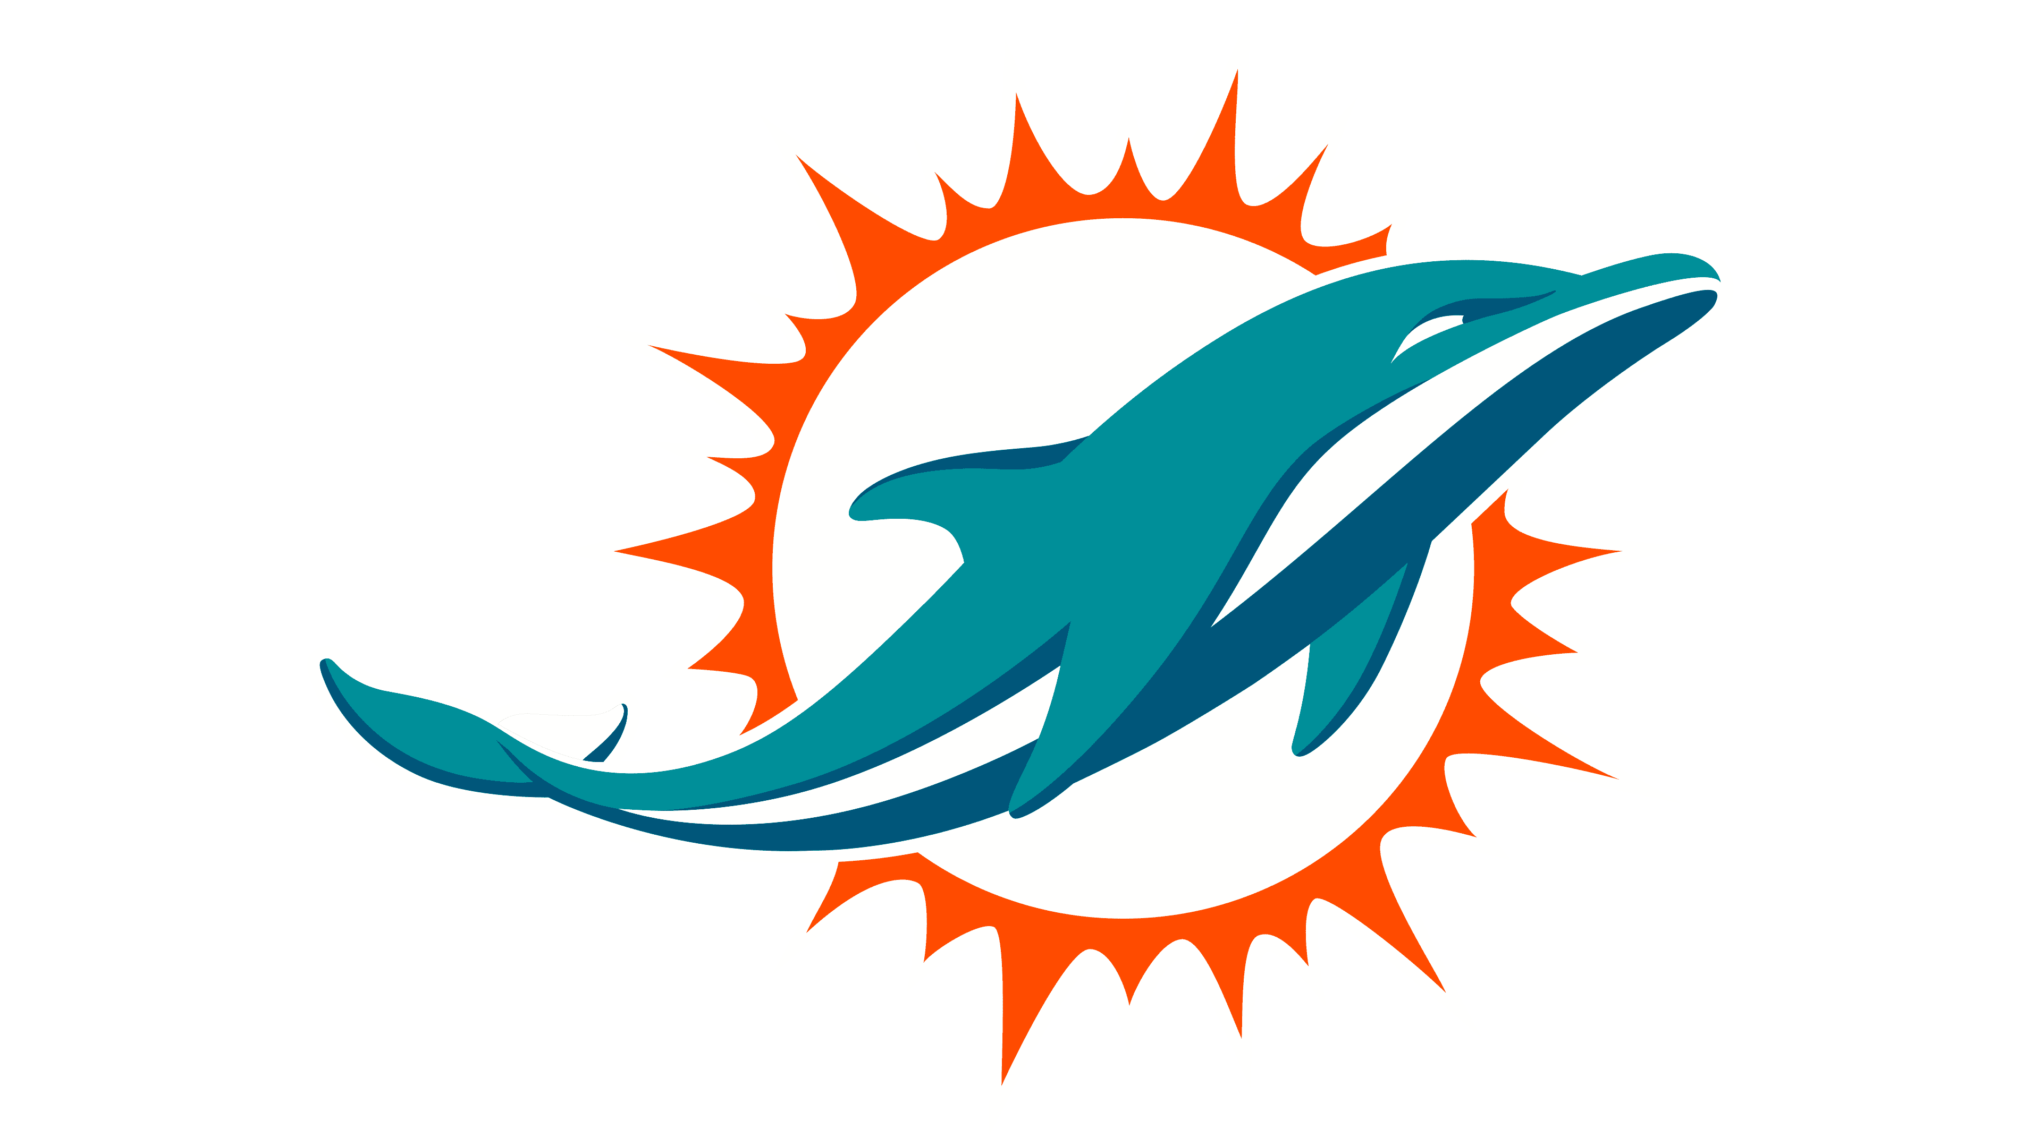

All members who wish to participate in football and or cheer programs with the Pleasant Grove Dolphins organization will be required to participate in the following:

All fundraisers organized by the designated sport your athlete is participating in. Or the option to buy out for $100 (if appliable) This applies to athletes participating in any age group of the football program. These guidelines align with the Pleasant Grove Dolphins by-laws

Any athlete participating in the Pleasant Grove Dolphin Cheer program will be expected to participate and adhere to all guidance from the Cheer Coordinator and Co-Cheer Coordinator regarding fundraising. A buyout option may be provided for each fundraiser at the approval of the Cheer Coordinator and Co- Cheer Coordinator.

Parent/Guardian Signature Date

Name of Participant (s) Sport

