Pleasant Grove Dolphins Football Equipment Rental Agreement

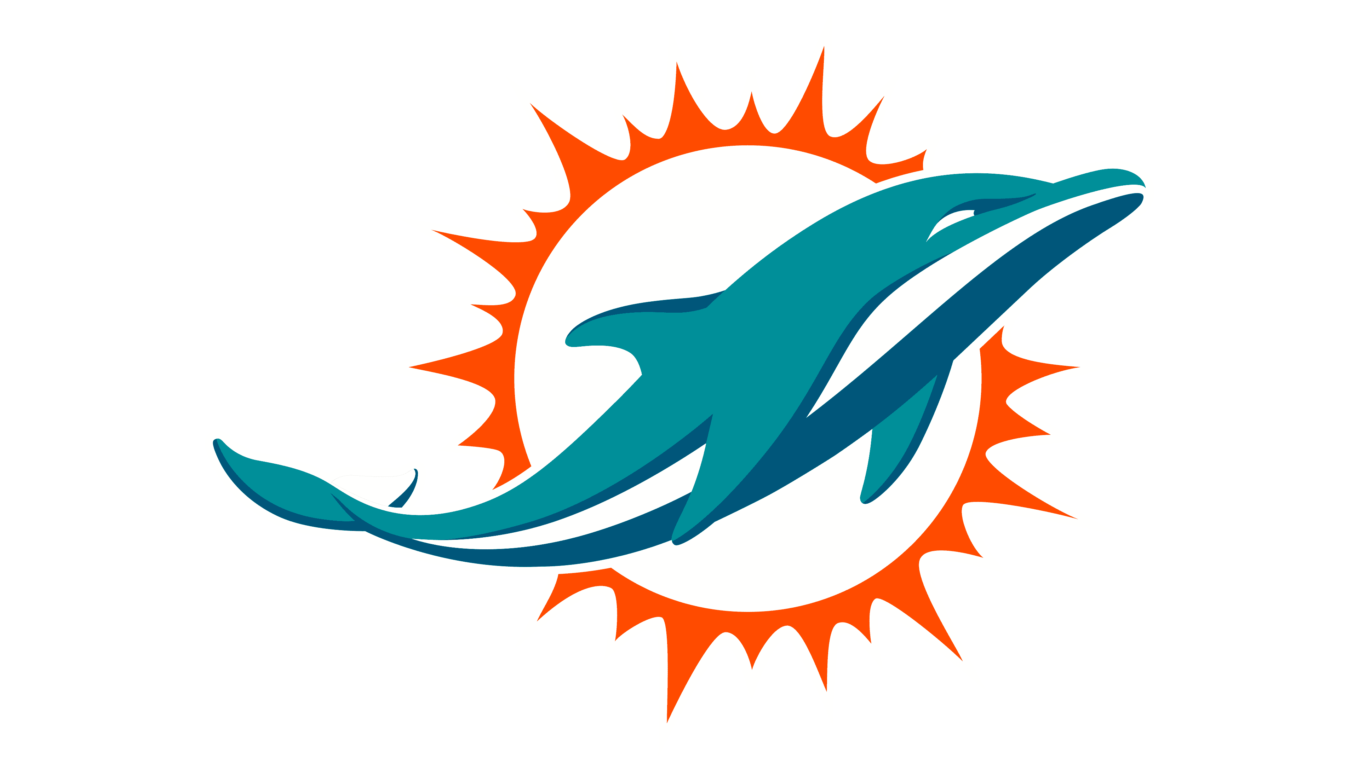

Each football player will receive an inspected helmet and shoulder pads for the season. There is a mandatory $100.00 deposit on a postdated check for 11/1 (of current season year). The fee will be returned via original check or cash, once equipment is returned to the organization. Equipment is due immediately following the last game of the season. If equipment is not turned in by such date the $100.00 will be deposited. The equipment rented to me by the Pleasant Grove Dolphins Football and Cheer organization is to be used only for GBCYFL activities. Any violation of this agreement is subject to a $100.00 fine.

I have read and understand this agreement.

Parent/Guardian Signature Date

Name of Participant (s)

