Pleasant Grove Dolphins Football and Cheer Social Media Contract 2026-2027
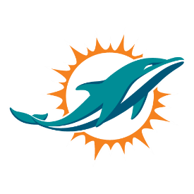
This policy contains guidelines for the Pleasant Grove Dolphins Football & Cheer community engaging in social media use.
Social media refers to any online tools or functions that allow people to communicate and/or share content via the internet. This social media policy applies to platforms including but not limited to Facebook, Twitter, SMS, Snapchat, etc. Any other online technologies that allow individual users to upload and share content.
When using social media, the lines between public and private, personal and professional, may be blurred. When posting content online there is potential for that content to become publicly available through a variety of means, even if it was intended to be shared privately. Therefore, you should refrain from posting any content online that you would not be happy for anyone to see. If you are online, you are on the record—much of the content posted online is public and searchable. Be sure to always act responsibly and ethically.
I understand the policy of the Pleasant Grove Dolphins Football and Cheer organization that I will NOT use social media, group texts, chats, messages, emails, etc. for use to bully, harass, or threaten any other adult or child that is a member of the Greater Bullitt County Youth Football League. I understand that any of these actions will result in automatic disciplinary actions in accordance with the GBCYFL Zero Tolerance Policy.
I understand that our Facebook page is for informational purposes only. Please refrain from disclosing any frustrations you may have with the program on all social media outlets. Please address all issues, complaints and or concerns directly to your PGD Board Members.
Parents, Coaches and Board Members agree to the following:
- I will NOT post or share any content that is abusive, harassing, threatening, demeaning, derogatory, negative, or defamatory regarding GBCYFL teammates, parents, coaches, board members, or game officials.
- I will NOT post or share any content that includes insulting, obscene, offensive, provocative, or hateful language.
- I will NOT post or share any content, which it said in person during the playing of the game would result in a breach of the rules of the game
- I will NOT post or share any content in breach of GBCYFL Zero Tolerance Policy, anti-discrimination, racial discrimination, sexual harassment, or other similar policy.
- I will NOT post or share anything that is dishonest, untrue, or misleading.

If you do have any issues, please contact your PGD Board Members.

I have read understand the terms in this contract.

Parent/Guardian Signature Date

Name of Participant (s)

