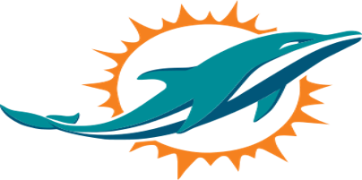

Pleasant Grove Dolphins Football and Cheer Program
Parent Guidelines 2026-2027

I recognize and accept my responsibility as a representative of the Greater Bullitt County Youth Football League and Pleasant Grove Dolphins Football and Cheer Program and pledge to follow this Parent’s Code of Conduct:

- I will limit my comments to positive reinforcement and encouragement to my child and his/her teammates. I will lead by example in exhibiting sportsmanship and fair play at every practice and game/cheer competition. I will encourage this behavior from other coaches, players, officials, parents and supporters
- I will place the emotional and physical well-being of my child ahead of a personal desire to win.
- If my child develops a behavior-related problem that repeatedly disrupts practice and/or games, I promise to work with my child’s coach to resolve the problem.
- I promise to treat other fans, coaches, players, and officials with respect, regardless of race, sex, or ability, and I will expect to be treated the same in return.
- I will not engage in physical or verbal confrontations with players, coaches, officials or other fans before, during or after practices or game/cheer competitions.
- I will refrain from the use of foul or offensive language.
- I will remember that as a fan, I represent the Greater Bullitt County Youth Football League. I understand that any concerns about officiating and/or coaching during a game must be directed to the team Head Coach/Sponsor. I also understand that poor behavior during practices, games, may result in expulsion from the practice field or gym.
- I will abide by the “24 Hour” Rule and will not discuss or approach coaching staff/ sponsors with disagreements or comments regarding said game/cheer competition until 24 hours after the competition.
- In the event that I have any comments, concerns, disagreements, upsets with anyone within the program or the league, I will approach my team head coach or sponsor first. If my immediate issue can not be resolved, I understand that I can then go to the appropriate Cheer or Football Coordinator and if my issue is still unresolved, I can approach the Program Chairman and from there, I understand that I will have the opportunity to speak to the entire PGD Board about my immediate issue.
- I will NOT use social media, group texts, chats, messages, emails, etc. for use to bully, harass, or threaten any other adult or child that is a member of the Greater Bullitt County Youth Football League. I understand that any of these actions will result in automatic disciplinary actions in accordance to the GBCYFL Zero Tolerance Policy.

________________________________________ ________________________________________
MEMBER PRINT NAME MEMBER SIGNATURE

