Pleasant Grove Dolphins Football and Cheer Refund/Quitting Agreement

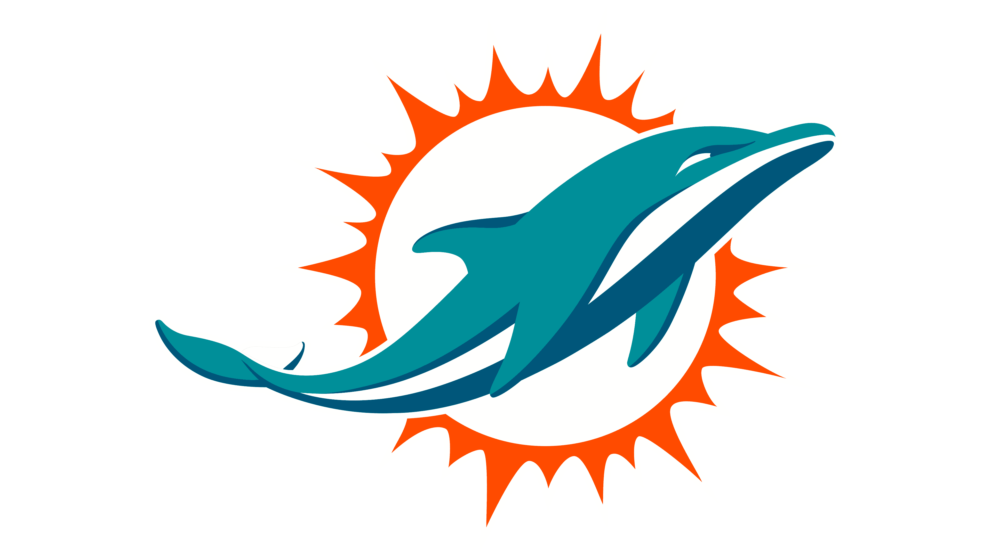

I understand it is the policy of the Pleasant Grove Dolphins Football/Cheer organization that refunds may be given up until two (2) weeks from the first practice date (or two (2) weeks from the child/children’s start date). If a child chooses to quit after this time, no refund will be given. I also understand that all equipment will be returned at the time of quitting and player will not be able to return to practice or games once they have formally quit.

I have read and understand this agreement.

Parent/Guardian Signature Date

Name of Participant (s)

