CDMB Meeting
Wednesday February 22, 2023 @ 6:30pm
Attending Members: Kyle, Barry, Mark, Fiona, Pat, Mike, Justin,
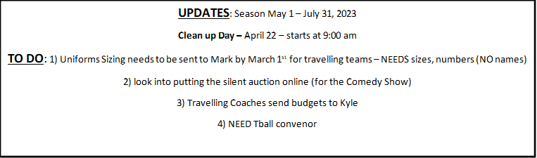Absent: John, Don, Karen, Sam, Cassandra, Craig, Brian,

Baseball Meeting – February 22, 2023

Goodbye:
-we are sadly saying good bye to Charlene – thank you for all of your time and dedication to the league. We’ll miss you!
Finances:
-League paid $2000 for hats (travelling – will get reimbursed)
-241 kids registered so far (2 months left to go)
-estimating 300-400 registered in total – (376 last year)
Fundraising:
-Looking into sponsorships on diamonds again this season
-Comedy Show March 4th – estimated $2000 for the league (plus silent auction and 50/50)
- House league - Raffle Fundraiser (need someone to organize this)
-Prizes for top sellers…?
Schedule:
- Tball – Tuesday or Wednesday (parent choice)
- Rookie – Monday and Thursday
- Minor – Tuesday and Wednesday
- Intermediate – Monday and Thursday
- Senior – Tuesday and Thursday
Travelling Teams:
- 10U – Justin (tryouts completed)
- 10U B – Mark (tryouts will begin late April)
- 12U – Trevor (tryouts beginning of April)
- 13U – Pat (tryouts completed)
- 14U – Travis (tryouts started)
- 19U – Kyle (tryouts started)
-12U to 19U – participate in CANAM (scheduling ongoing)
Cornwall Tournament Dates:
8U – Aug 11-13, 10U – July 7-9, 12U – June 16-18, 13U – June 30-Jul 2, 14U – June 2-4, 19U – Aug 18-20
-concerns – some teams complained about lack of shade during tournaments – look into tents/shelters
-for tournaments, teams/families are responsible for field set up, washrooms being cleaned, any fundraising (if applicable) throughout the weekend – NOT responsible for score keeping, etc. anymore)
Uniforms:
-Sizing needs to be sent to Mark by March 1st for travelling teams – NEEDS sizes, numbers NO names
-Majors and 8U (order uniforms in advance and will pay league back later on)
-league plans to keep some uniforms in stock (buy and resell for next season, etc)
-approx $300 for entire uniform (per player)
South Stormont:
-partnership starts this season – estimating about 100-120 more kids to register with our league
-R.O – tball and coach pitch practice/games – other divisions at the park
Clean up Day – April 22 – starts at 9:00 am
-paint, rake, bbq (look to get paint in spray cans for touch ups during the season)
Batting Cage:
- most important update/reno for this season
-$50/travelling player to help with cost of batting cage (roughly $3500 – approved by exec.)
-NEEDS – dug out around it (electrical), fix holes in fence, new netting ($1000 approx)
-going forward, netting needs to be removed and stored over the winter months
-Plan is to rent out batting cage: booking/payment online
TBall Convenor NEEDED:
-position needed
-Options: 1) hire (possibly teenagers) to run the tball convenor position (approx. $1000 for the season) OR 2) offer parents to wave their child’s registration fee to be convenor.
End of Year Banquet:
-Sept. 22, 2023 (location to be determined)
-start holding a year end banquet every season for awards, etc.
-trophies at each age level (displayed in trophy room in rat’s nest)
-medals to take home
-Fiona will help

