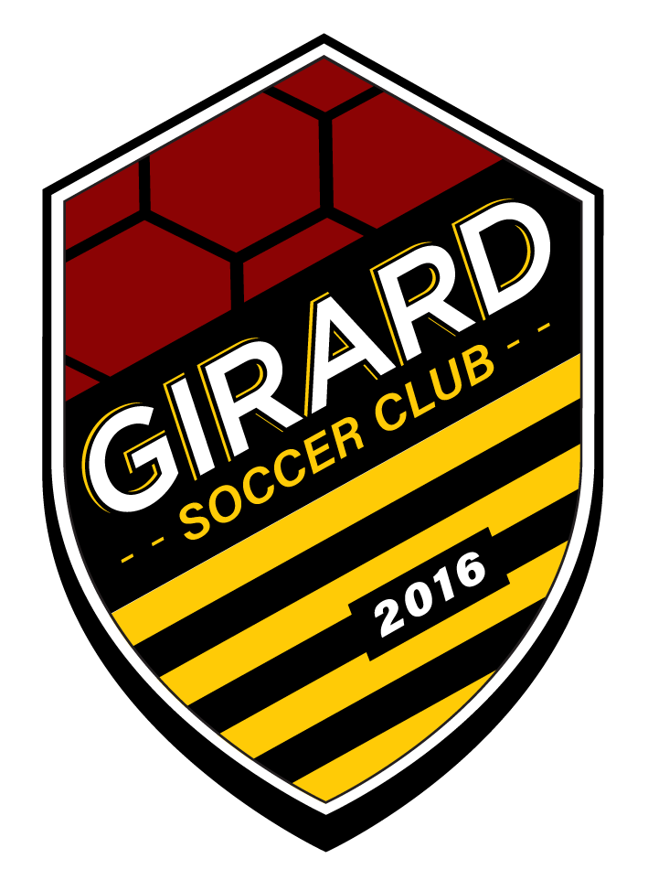

Girard Soccer Club
2026/2027
Parent Agreement

As an organization committed to the continued promotion of a Safe, Secure, and Supportive environment for all, Girard Soccer Club seeks to embody the highest standards of courtesy, sportsmanship, and exemplary behavior among its members. As a crucial part of Girard Soccer Club, families are expected to demonstrate and adhere to the behaviors in this Parent Agreement and the US Youth Soccer Code of Conduct Policy while engaging in activities related to Girard Soccer Club. All violations will result in the ordered consequences as follows:

*Girard Soccer Club reserves the right to terminate immediately if the club should see fit.

1. Verbal warning, 2. Suspension from all club events,
3. Expulsion from Girard Soccer Club entirely.

Team & Player Support

- Help your child to understand the holistic values within the Player Code of Conduct.

- Adhere to team schedules and obligations.

- Have your child at the field at the expected time.

- Ensure that your child is dressed appropriately for each game and training.

- Inform your child’s coach in a timely manner when school, family or other obligations will prevent your child from attending practices or other team activities, or the need to arrive late or leave early.

- Discuss individual player concerns privately with your coach. Wait 24 hours after any club event to approach a coach or staff member.

Sportsmanship & Personal Conduct

- Expected to set a good example by modeling the highest standard of sportsmanship.

- Cheer in a positive manner. Negative criticism towards your child and other players is UNACCEPTABLE.

- DO NOT give tactical instructions or attempt to coach from the parents sideline. Parents’ instructions are confusing and can be possibly contrary to coaches’ instructions.

- Show respect and courtesy to match officials. Do not verbally criticize the decisions of referees or assistant referees. It is the coaches’ job to interact with referees in the proper manner.

- Show respect and courtesy to Girard Soccer Club: staff, coaches, and players.

- Show respect and courtesy to opposing players, coaches, and parents.

- Refrain from using profane or abusive language during any club events.

- Recreational Drug and Tobacco and Alcohol use during any club match is UNACCEPTABLE.

- This sportsmanship and personal conduct code applies to in-person as well as social media interactions.

Club & League Policies

- Observe all rules and policies of Girard Soccer Club and all affiliated competitions.

- Pay club and team fees in accordance with required payment schedules.

- I understand that according to club policy refunds are only issued, OR automatic payments suspended by 3:23 Athletics, if a valid medical excuse is provided, the program is called by 3:23 Athletics, or by prior agreement at the director’s discretion. Players withdrawing for any other reason, an additional one month’s dues will be applied.

- Show respect for playing fields and facilities.

- Provide volunteer support for team and club activities.

- When concerns arise regarding your child’s coach, club rules, or club policies, bring them to the attention of the correct channels in a timely and discrete manner.

Chain of Grievances (order in which to follow with complaints or confusion)

- Give a minimum 24 hour grace period

- Your child’s coach

- Owner & Sporting Director (Absolute last resort and email written concern)

Behavioral Expectations

Parents are expected to model the highest standards of conduct when attending any Girard Soccer Club matches, practices, or tournaments. Any of the following behaviors will NOT BE TOLERATED and is grounds for removal of a parent from an event or the club:

*Possession or use of any illegal substance and or weapon

*Engagement in illegal activity

*Consistent dissent towards coaches, players, match referees, other parents, and Girard Soccer Club staff

Code of Conduct Violations

1st Offense
- Formal verbal or written warning, including parent/guardian contact.

2nd Offense
- Suspension from all club-related events, sidelines of games, friendly scrimmages, and tournaments for an extended period of time.

3rd Offense
- Immediate permanent expulsion from Girard Soccer Club.

Sidelines - Specific Code of Conduct

- I will take no action that causes public embarrassment for myself or Girard Soccer Club, as well as action that brings myself or the club into disrepute in the community.

- I will not coach from the sidelines. My words will be used only for encouragement from my child and other players.

- I understand that playing time is earned through hard-work, player performance & attendance at training, and player development level - NOT by team or tournament fees paid (Re: Select program greater than United program)

- I will not make negative comments about club coaches or staff-members.

- I will use appropriate language during all club events.

- I will not use obscene language, gestures which denigrate, ridicule or mock a person or persons based upon their race, gender, sexual orientation, economic status, nationality, country or origin or political affiliation.

- I will stay away from bench areas under all circumstances unless called over by one of the club coaches.

- I will not physically or verbally intimidate any coaches, players, referees, fans, or volunteers during any club event.

- I am responsible for the actions of all my guests in attendance at club events. A guest of a parent or legal guardian will be held to the same disciplinary standard as I am under this Code of Conduct.

- I understand that any parent or legal guardian who is removed from a game by an official may result in such parent or legal guardian also being automatically suspended for a minimum of three games by the club. Any parent or legal guardian that is removed from a game by an official two times during any soccer year may be banned from ALL remaining games for that year.

- I will not use profane or abusive language at any club event.

- I will wait 24-hours, and write an email to the appropriate channel sharing any concern and asking to schedule a time to discuss it, if appropriate and logistically possible.

- I will respect all decisions regarding player placement made by the clubs coaches and/or staff members. I will respect all decisions made by the club’s coaches and staff members during training, games and other club events. Any and all questions can be directed to the correct channels as listed in this Code of Conduct.

*Failure to meet any of the above listed responsibilities after notification of the same.

*Cause or attempt to cause injury to or abuse any member of the club or their opponents.

I have read and understand the Parent’s Code of Conduct and agree to abide by their letter and spirit as a Girard Soccer Club parent.

*Signature placed on file during registration process.

